
LockIn
Reduce screen time to win money with friends!
Final Report

TEAM MEMBERS

Ethan Chang (He / Him) - Organizer & Developer


Jessica Cao (She / Her) - Lead Developer


Julia Luyten (She / Her) - Organizer & Designer



Ingrid Nordberg (She / Her) - Lead Designer

Problem & Solution Overview
As college students ourselves, burnout and stress is a regular issue that consumes the lives of us, our peers, and people we interact with. Continuously throughout our needfinding, which we touch more on below, we found a common theme relating to healthy behaviors: it’s hard for people to avoid digital distractions and balance their work, and these screen-time obsessions lead to stress.
Early on, our key insight & value prop was that while screen time is heavily discussed with Apple’s even building their own “Screen Time” feature, behaviors are truly encouraged through social and monetary incentives are effective – this concept was reinforced throughout our needfinding, assumption testing, and prototyping processes. Built around this insight, we are excited to announce LockIn, a social app that motivates people to reduce screen time by competing against friends to win money. Users are incentivized to spend less time on their screens as they compete with and stake money against other people and improve their healthy habits.

Needfinding
We started with a wide funnel, casting a broad net by designing for healthy behaviors in general, and then narrowed it down to the field of stress and burnout; important and pain points that we & many of our peers & friends from all over experienced in some frequency. In our team of four, we approached a diverse population of people sampled from Stanford, non-Stanford, SF, outskirts of Palo Alto, and even individuals from home – our outreach persisted on different forums, online ones like Fizz and Nextdoor along with across campus and different cities that were in (we did one on the Caltrain!) In addition to typical diversity considerations like age and gender, we also wanted to interview people facing a range of stressors because we didn’t want to limit ourselves to our own biases.
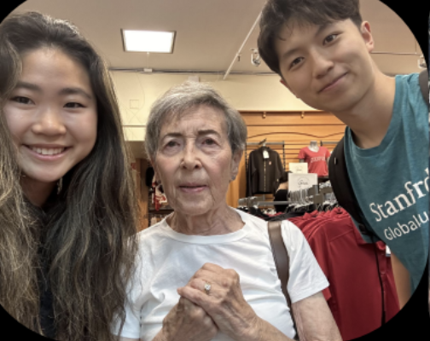
In Assignment 1, we interviewed four individuals, all in person. We asked questions like “What is your relationship with stress?”, “What is stressing you out right now?” and “Do you have any ways of coping with stress that you try to avoid?” We strove to ask open-ended questions to further reduce bias in the interviews and yet, looked for insights in high frequency pain points that they had. Throughout, we did not financially compensate the interviewees.

Meet Mary: the 84-year old single mother we met at Stanford Bookstore!
One interviewee was Sarah, a 22-year-old biochemistry PhD candidate, who spoke about heavily relying on rituals to increase her sense of control of her stress, especially surrounding sleep. She would engage in deliberate bedtime routines because it made her feel like her actions were increasing her productivity and made her feel more in control when her life felt very stressful and out of control.
Mary, an 84-year-old from Minnesota visiting her friends, who spoke about how she was a single mother to three kids and had recently experienced a death in the family. She was adamant about keeping little healthy habits that would add up to a bigger health benefit, especially because of her advanced age.
John, a 24-year-old from Greece, who had started experiencing burnout after his job as an accountant ramped up. His poor stress management caused him to struggle with his diet, which further exacerbated his stress.
Mikaela, a 37-year-old religious studies PhD candidate, whose experience of burnout included realizing she was burned out when she noticed she was wasting more time being exhausted and not doing anything than actually being productive. She described her goal as balance, in both her life and her work.
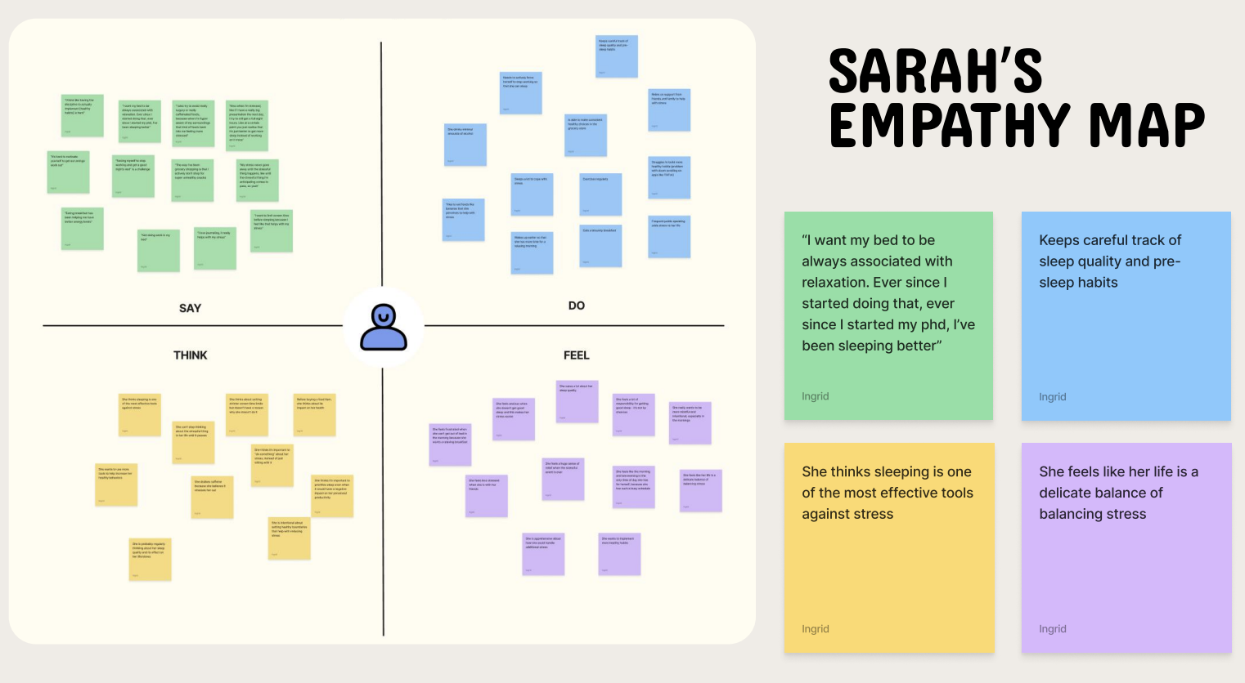
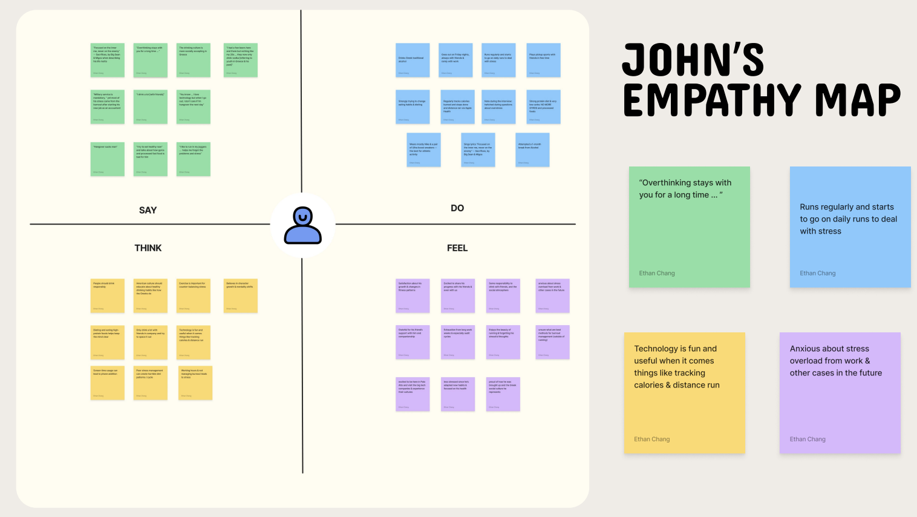

Empathy maps for Sarah (interviewed by Ingrid) and John (interviewed by Ethan)

Result Synthesis
We synthesized our findings by creating empathy maps for each candidate, coming together as a team to discuss the findings and maps in depth, and drawing insights from our conversations. While we hadn’t found a direct niche within healthy behaviors, we learned a lot with testimonials from individuals like John who applauded using digital platforms as inspiration citing Big Sean and the Migos’s song Sacrifices “You know the song ‘Focused on the inner me, never on the Enemy’ it’s very motivating.” Our insight here was that for John, his burnout was both exacerbated and calmed by “fun, digital metrics.”
From each conversation, after synthesizing our empathy maps and reviewing our interview notes, where one member interviewed and at least one other took notes, we ultimately deduced a few main overarching themes. We learned from that people want small, manageable strategies to prevent burnout, crave security when they are building a stress-protective system, and that the most powerful stress-management strategies is a self- motivator like rituals because their power comes from their perception as a ritual and the continued pressures to maintain individual consistency.
In Assignment 2, we continued our next stage of needfinding, by delineating between interviewees with persona-esque names for additional empathy building – we wanted to dig deeper and explore a broader set of individuals, to identify more concrete needs.

Hiding their names, we interviewed the “Supported Engineer” who transitioned from a high-pressure, 0 to 1 startup environment to a much more calm corporate environment at Raytheon, the “Compassionate Healer” who feels burnt out by the healthcare system, the “Well-Being Warrior” who experiences work stress even with healthy physical habits, and the “Distracted Innovator,” who despite bragging to friends about the physical & digital work he puts into his startup, felt most drained by excessive screen time.
We found these interviewees in places ranging from the Caltrain to a hackathon in SF, and again made empathy maps to assist us with insights. We found that while physical health practices may help alleviate stress, they don’t address the underlying emotional or relational factors contributing to burnout, and that digital distractions, especially from distractions like social media and entertainment apps, are a major driver of burnout in tech-savvy environments.

POVs and HMW’s
POV 1: CONNOR
We met Connor, a college dropout & startup founder previously at UCLA.
We were surprised to notice: that, despite Connor’s deep passion for technology, he felt stressed and deeply dissatisfied not with the work itself, but with his excessive screen time on social and entertainment apps that he found himself drawn to during work.
We wonder if this means: the constant pressure to engage and stay connected, twelve hours spent on digital distractions and inability to detach from non-essential digital interactions – is causing him to experience burnout.
It would be game changing to: help Connor cut through the noise of non-work related digital use, allowing him to focus without the emotional toll of constant connectivity.

HMW’s:
- How might we create a more mindful relationship with technology for those who are deeply immersed in it?
- How might we create spaces or moments in the day for tech professionals to recharge away from screens?
- How might we support startup founders in developing healthier work environments that reduce stress caused by constant connectivity?

POV #2: SARAH
We met: Sarah, a biochemistry PhD candidate at Stanford who walks a thin line
between healthy stress and burnout.
We were surprised to notice: she keeps careful track of sleep quality and pre-sleep habits, but this concern about her sleep is causing her even more stress than the actual sleep itself.
We wonder if this means: wonder if this means she’s ultimately terrified of losing
control over her rituals.
It would be game changing to: for her to feel more peaceful when her rituals are
disrupted.

HMW’s:
- How might we encourage people to be more adaptive with their sleep habits in ways that reduce stress?
- How might we encourage Sarah to view disruptions as a challenge instead of turmoil?
- How might we create tools or resources that focus on sleep quality improvement without triggering control-based anxiety?

POV #3: TIM
We met: Tim, a real estate developer from Palo Alto who loves the outdoors as a mode of stress reduction (context: we met him while hiking the dish.)
We were surprised to notice: despite having a daily exercise and meditation routine, Tim still feels burnt out from being overwhelmed by relational/work stress at least once every month, and has to take a step back from responsibilities when he experiences this.
We wonder if this means: burnout is not effectively prevented by physically healthy habits alone
It would be game changing to: identify what the proper mitigation strategy of his burnout is.

HMW’s:
- How might we develop a burnout prevention system that goes beyond physical health habits like exercise and meditation?
- How might we help Tim identify non-physical strategies to manage relational and work-related stress?
- How might we support Tim in managing work-related stress without having to completely step back from responsibilities?

We brainstormed over 15 HMW’s for each individual; our synthesis involved a form of color mapping, where we chose HMW that best fit the insights by indicating emojis (see below) for each individual, incorporated continued feedback from our TA, and selected the top HMW based on most votes. Each emoji represented a team member.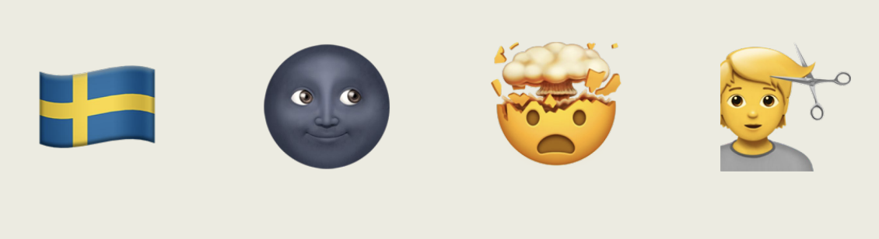After selecting the most appropriate HMW as a group for each individual we met, we started brainstorming solutions for each HMW with the lecture reminders in mind. A common theme we found here was that stress was related to poor habit management – from digital distractions to irregular sleep quality and physical exercise as a “placebo” burnout prevention mechanism – the individuals we talked to and understood continued to feel unproductive, overworked, and tired. Often, these were tied and interconnected – Sarah and also found herself on nights with poor quality, distracted on her phone or “doom scrolling” and John facing exhaustion from social media in the back of his head and directly impacted his work-related burnout. We knew this ourselves too, the relationship between digital screen and work-life balance is hard to fix, given how immersed we are with our devices today – people struggle to avoid digital distractions and balance their work, and these screen-time obsessions lead to stress.

Top 3 Solutions
For Connor and his HMW – improving his relationship with screen time while maintaining his status as a die-hard founde – we came up with screen time staking; a social media app, like Strava, to reduce screen time with wagers and sharing your stats with friends. For Sarah and her HMW, a Screen Time Detox Box was the most appropriate and effective solution, a physical box to place your digital devices meant to remove literally tech before bed. Finally, Tim and his HMW, we proposed an Aromatherapy Subscription where users take an in-app quiz for preferences & get essences tailed to them monthly which they track their feelings and status on an app.

Experience Prototypes
Prototype #1: Screen Time Staking
Assumption: Gamifying healthy habits makes users more likely to stay consistent

Users set a screen time goal for the next day and “Venmo” $15 to us; we collected it and then if they achieved it returned it, else, we kept it. We included both monetary and social pressures here.
Results for this were significant & very quantifiable, and led us to increase our conviction
- Michelle found that her TikTok time went from 3 hours to 45 minutes, and her overall time spent was 6 hours to 3 hours.
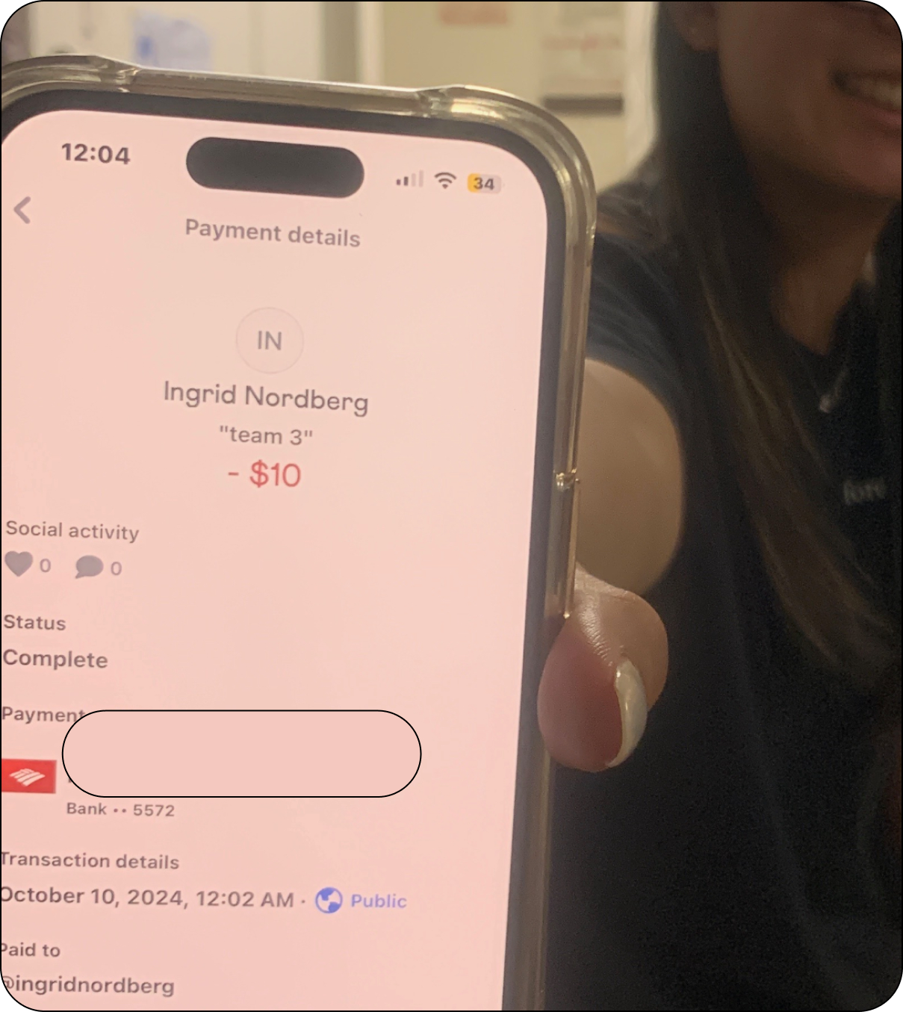
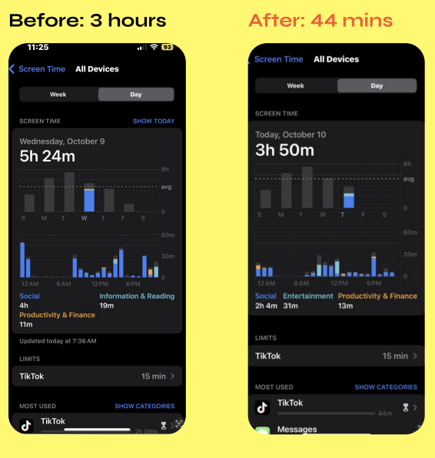
- Amber, an extreme user, who only averaged 1 hour a day on her phone but even this dropped by 50% to 30 mins!!

Both users reported that they were more productive and felt better about their habits after JUST ONE DAY. Amber sent a text saying “I would use this more, if I could win something …” which led us to a powerful insight, people were more likely to play if they had an economic incentive. We also thought

Prototype #2: Screen Time Detox Box
Assumption: Users will actually keep their phone in the box

Users were tasked to place their phone in a box while they did 1 hour of homework, and their behavior and feelings were analyzed and debriefed.
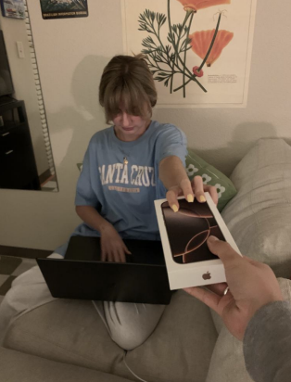
Live: User’s Phone Being Taken Away
We found that putting their phone in the box was an intentional act that made users feel more productive, and not seeing their phone by their side made them think about it less. They especially enjoyed the physical action of putting their phone in the box. However, it was still hard for users to deal with urges to go on their phone because they received notifications on their computer that made them want to go on their phone. We ultimately learned that while the box was somewhat effective at reducing screen time, it was not a foolproof solution especially because our users’ computers received the same notifications as their phones.

Prototype #3:
Assumption: Users think essential oils do something to help with stress
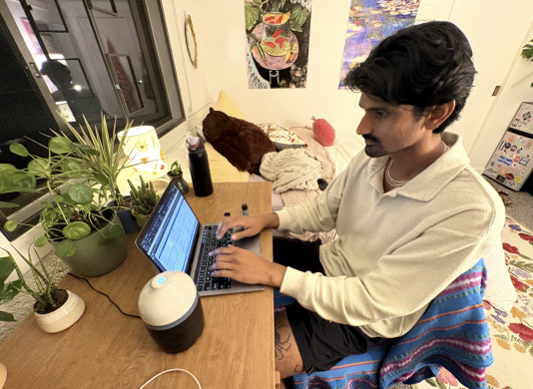
We asked high-stress users working at night to introduce essential oils into their space for 2 hours. After 2 hours, we evaluated whether their stress levels had decreased.

What worked with this prototype was that the essential oils were immediately relaxing to the user, and the learning curve was very low as it was easy to apply to the user’s wrist. However, the essential oils had only a short-term effect, and the user complained of headaches from the strength of the product. We learned that essential oils are likely only a short-term solution to stress, and we suspected the placebo effect was in play as well.

Design Evolution

Final Solution: Screen Time Staking
The solution we chose was Screen Time Staking, a social media app to reduce screen time with monetary incentives by competing with your friends. We chose this solution because we saw the most quantifiable changes compared to the other two prototypes. The essential oils prototype was net neutral or even net negative, as the user complained of headaches. The detox box prototype was not completely effective either, as users still felt urges to reach for their phones, showing that there was not enough incentive. The screen time staking solution, on the other hand, used both monetary and social pressures to cause screen time decreases of around 50% for both users. Building upon the solution and the insights we generated from our assumption testing, where users asked for “a monetary upside” to incentivize their participation, we introduced LockIn’s pot & staking concept where friends pooled their money together at the start and once someone is out, their money get redistributed to remaining winners.

Tasks
Simple Task: Join a pre-set competition with your login
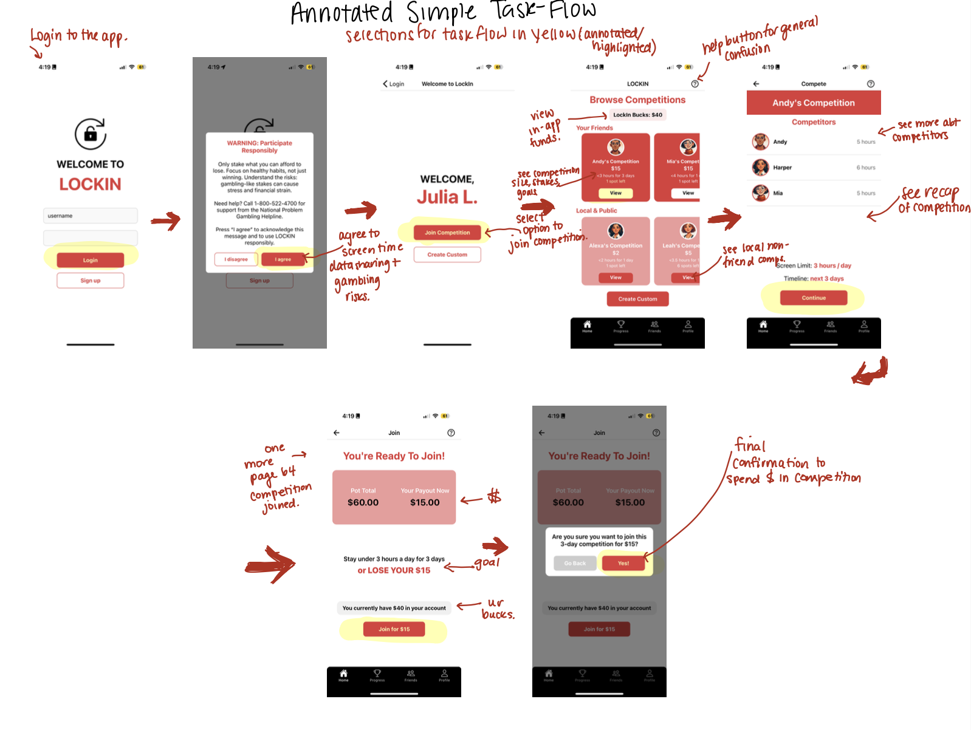
This task is important because it is the most basic, high frequency goal almost all users will want to complete when they download LockIn, as joining a competition is also simpler than creating one’s own competition and is the simplest, primary use to reduce screen time.

Moderate Task: Monitor the competition feed and compare analytics with friends
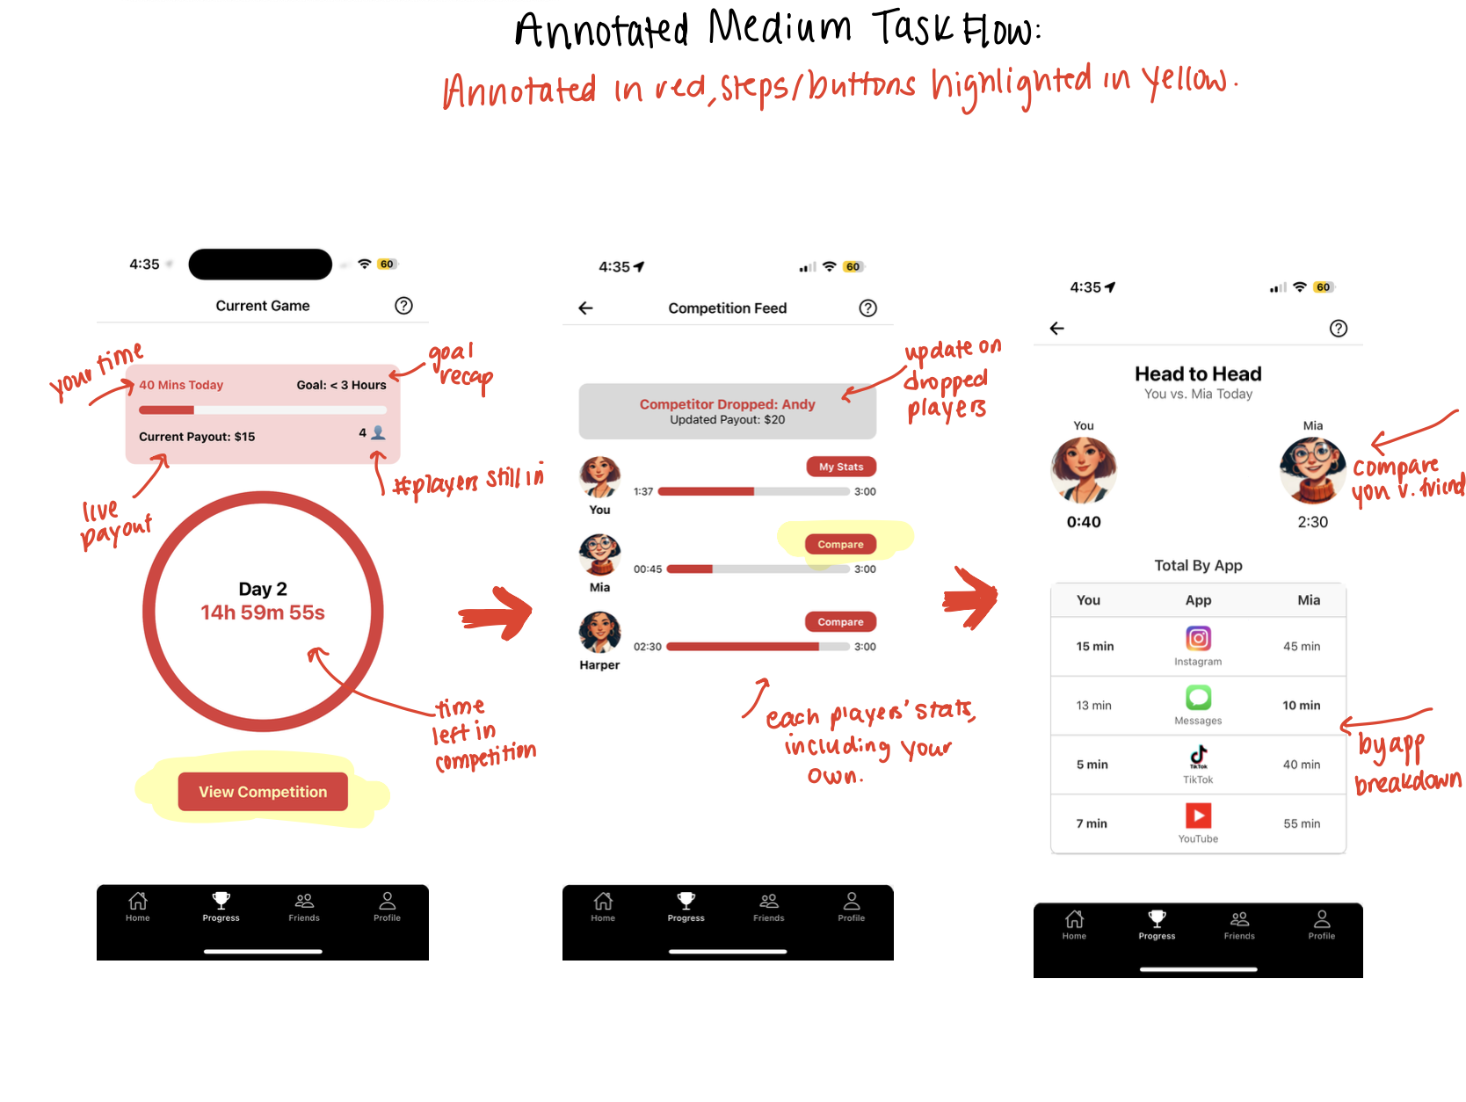
This task is important because Lockin is a social media app, and during a competition users would want to know where they stand with respect to their friends.

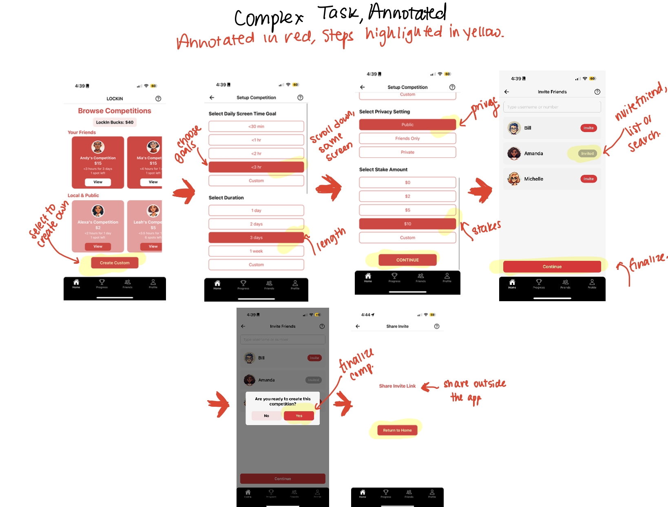
Complex Task: Make a custom competition; defining your preferred goals, stakes, and members; sharing invitations to the competition. This was our most complex task for mainly power users – its importance is how earlier tasks can be completed, without the ability to create your own for your friends or public competitions, there would be no competitions for other users to join. It also means that users have agency over the details, participants, and privacy of the competitions that they put their money at risk for and can create personalized invites for social accountability.

Design Evolution Visualizations and Rationale

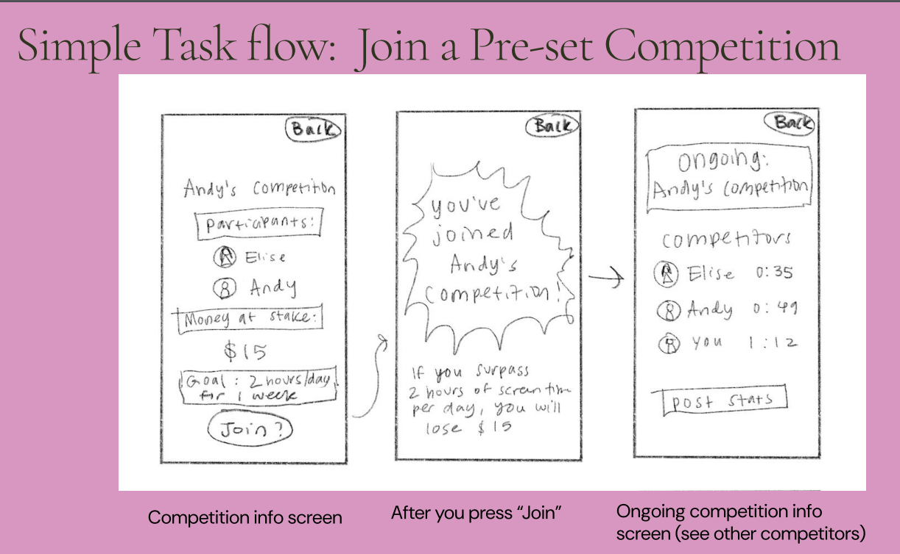
Simple Task Flow Evolution:

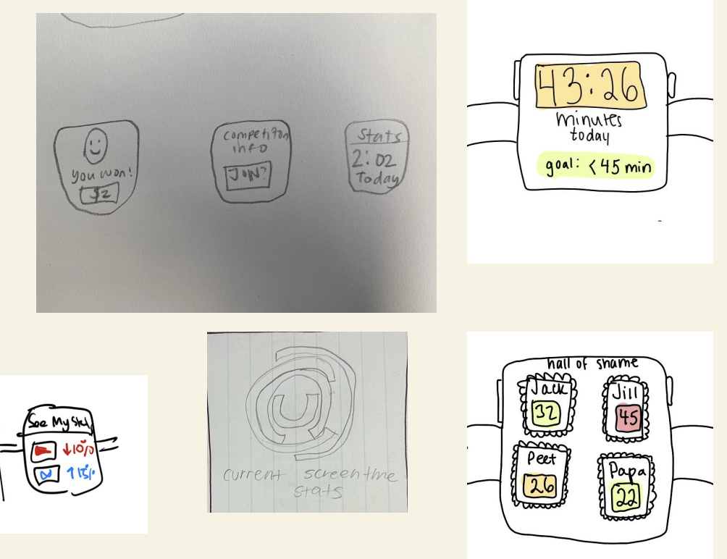
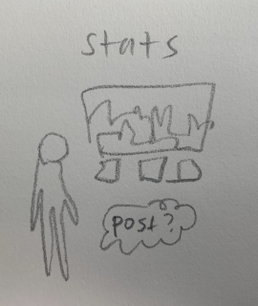
Our first UI iteration was our low-fi sketches – across all of us, we played around sketching different visualizations like the AR / VR medium, Apple Watch / smartwatches, and across iPad and iPhone; for the purpose of our platform, which aims to limit app usage on your phone, we chose to select iPhone as our medium to best “attack the root” of the problem going forwards. To support our rationale, over 90% of Americans own a smartphone compared to the 21% that own a smartwatch and large interfaces allow for better usability, efficiency, and feature development. Two possible disadvantages, we recognized were the medium could lead to increased app usage and gambling concerns. For prototyping, we generally aimed to capture the broad-strokes user flow of each task – what the high level action the user would be doing and a reminder to the overarching task they should accomplish, e.g an interface that would allow users to quickly see all details about a competition before joining it. We wanted it to emphasize the importance and excitement of joining a competition and add a page that would be a user’s “home base” with all the information and updates they could need during a competition.

Apple Watch / Wearables diagrams of LockIn AR/VR of Medium Tasks
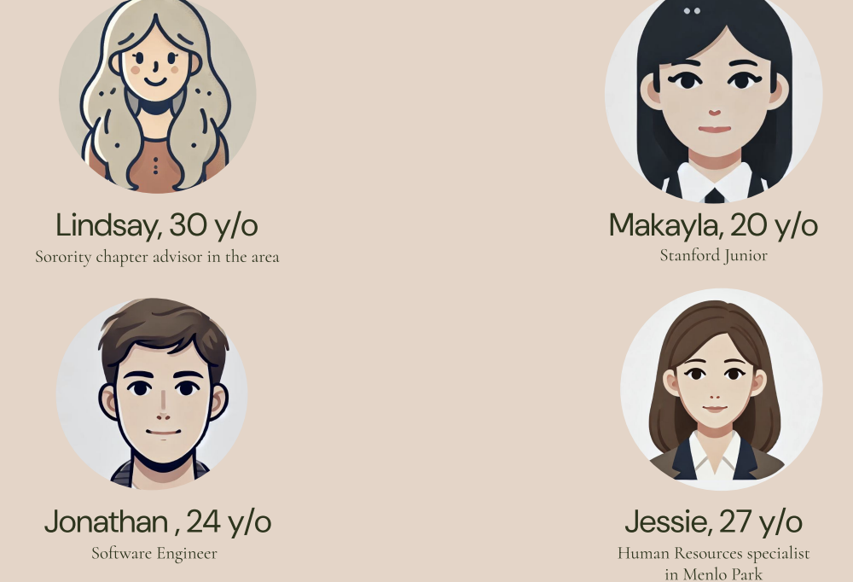
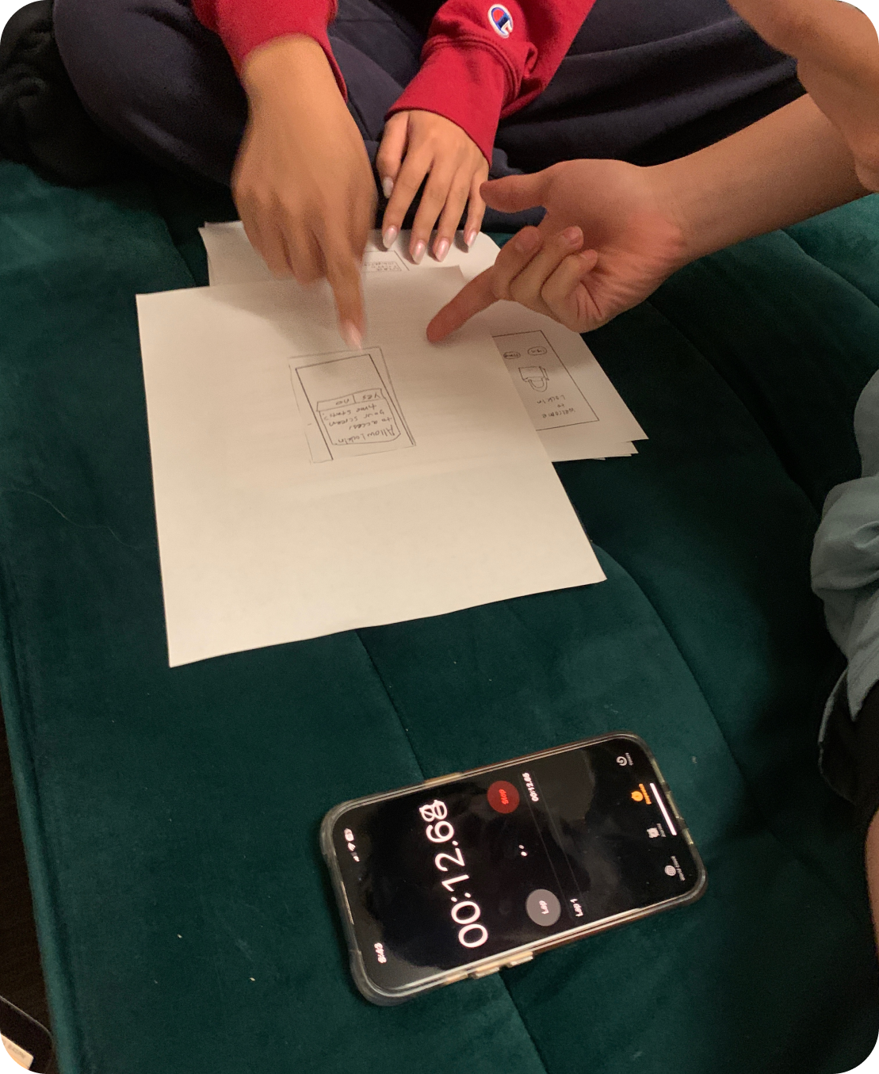
Evaluation Technique Between Low-Medium Fi:
We conducted usability tests and our Lo-fi prototype with paper prototypes, cut-out screens that we placed under a paper slider frame (more sustainable) 3 tester roles including a timer, a notetaker, and a facilitator. We measured # of misclicks, expression of confusion/excitement and engagement, and likeliness to use the app again. We recruited four participants across different demographics, but aimed for individuals that were our targeted age range of millennials and Gen-Z.

Feedback from Testing: (Paper prototype, paper slider, 3 tester roles to facilitate)
The big takeaways from our 4 participants we found were that users were confused on the “Andy’s competition” page about which icons were buttons and what the next user steps were. Users also found the app generally too cluttered, with other app logos being confusing paired with a messy analytics page design was not a strong indicator to what our app actually does. Some memorable feedback we got was in the Join Competition screen, one user noted “I don’t really know what to click here … change participants? Or the money? Can I join immediately? Another user asked if they were permanently stuck there. Users and our sectionees also found the line graph confusing and not the most visibly clear.
Major changes into our Medium-Fi Prototype
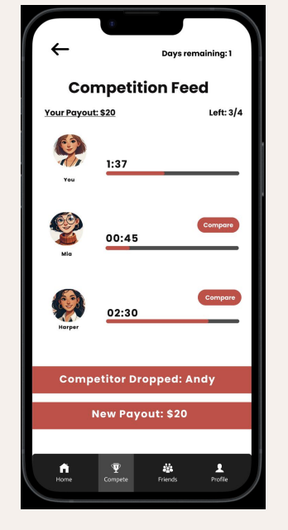
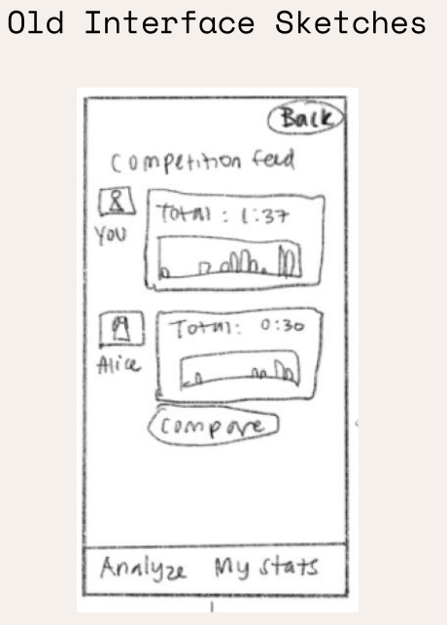
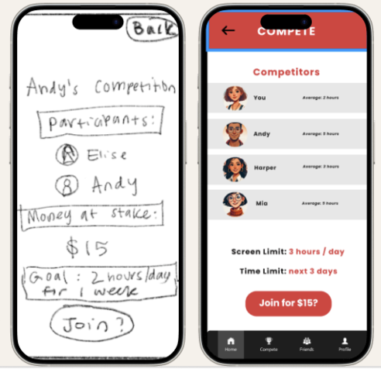
Our Medium-Fi involved taking our sketches, feedback, and the ProCreate version and the changes we made on ProCreate, into an interactive Figma with flows. The major visible features we modified were 1) adding a navigation bar to make usability and switching between pages easier, delineated labels more clearly, and 2) better grouping, labeling and removal of excessive text, logos, and distractions and 3) we reworked on Moderate task display to lock into the Current Game Screen and start minimalistic, which we talk more about in the next section. Other big changes: 1) on the Join Andy’s Competition page, we made major reworks separating the texts and clusters as per Gestalt Principles of Grouping and delineation of labels and pressable buttons. 2) a cleaner, visible my Analytics page, and 3) progress bars and payout information in Compete Feed.

Before and After Screens from Lo-fi to Hi-fi
For the Progress screens (on the right, above), we were advised to hone in on “radical minimalism” from Nava and in our earlier prototyping, we found that users often were a bit lost on what they were supposed to do from the clutter – the page had too much going on with the graphs and unnecessary visuals. It still remained unclear who was in the competition and who was dropped out; what alerts would be displayed. By examining these principles and further evaluation techniques we discussed in class like whitespace, we made a few major revisions here 1) adding clear language about payouts and having users being dropped, time period left and 2) replacing big charts with clean, spaced out progress bars to emphasize the importance on your status amongst competitors.
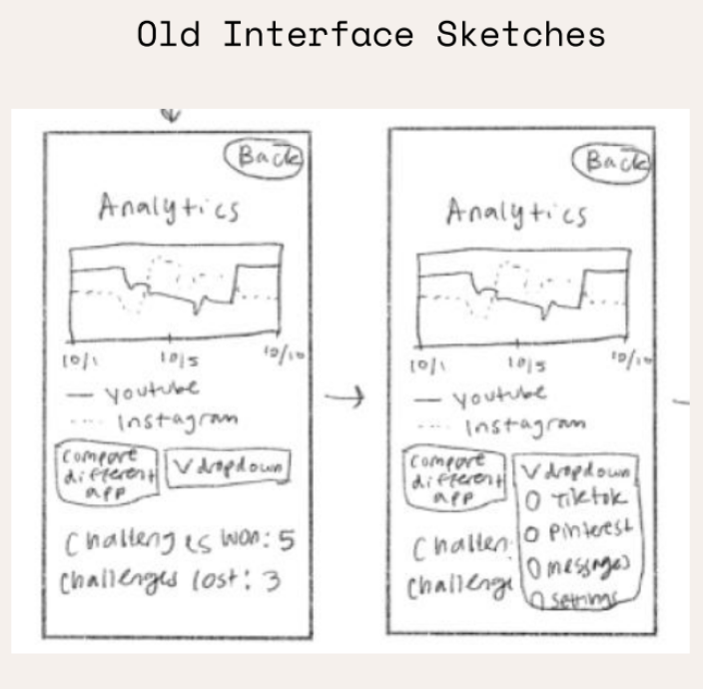
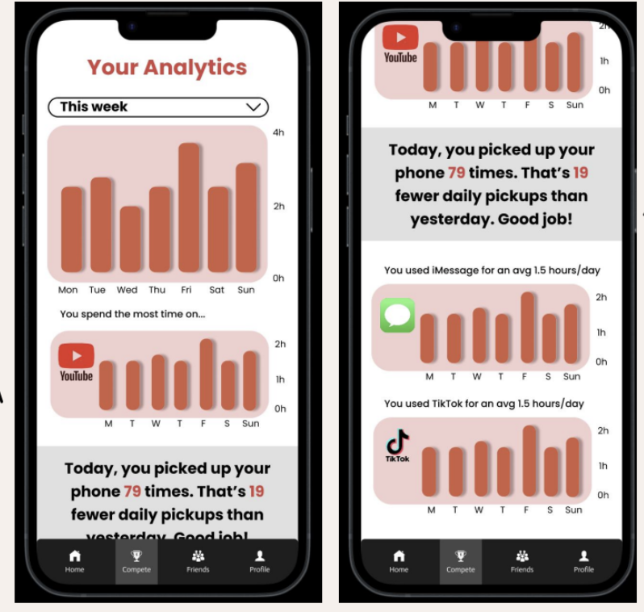
‘

Other Significant Changes: The Analytics Page
The main improvement in the analytics screens related to affordance and related cues like vertical scroll, clear text, important updates, bar graph replacement with a line graph.
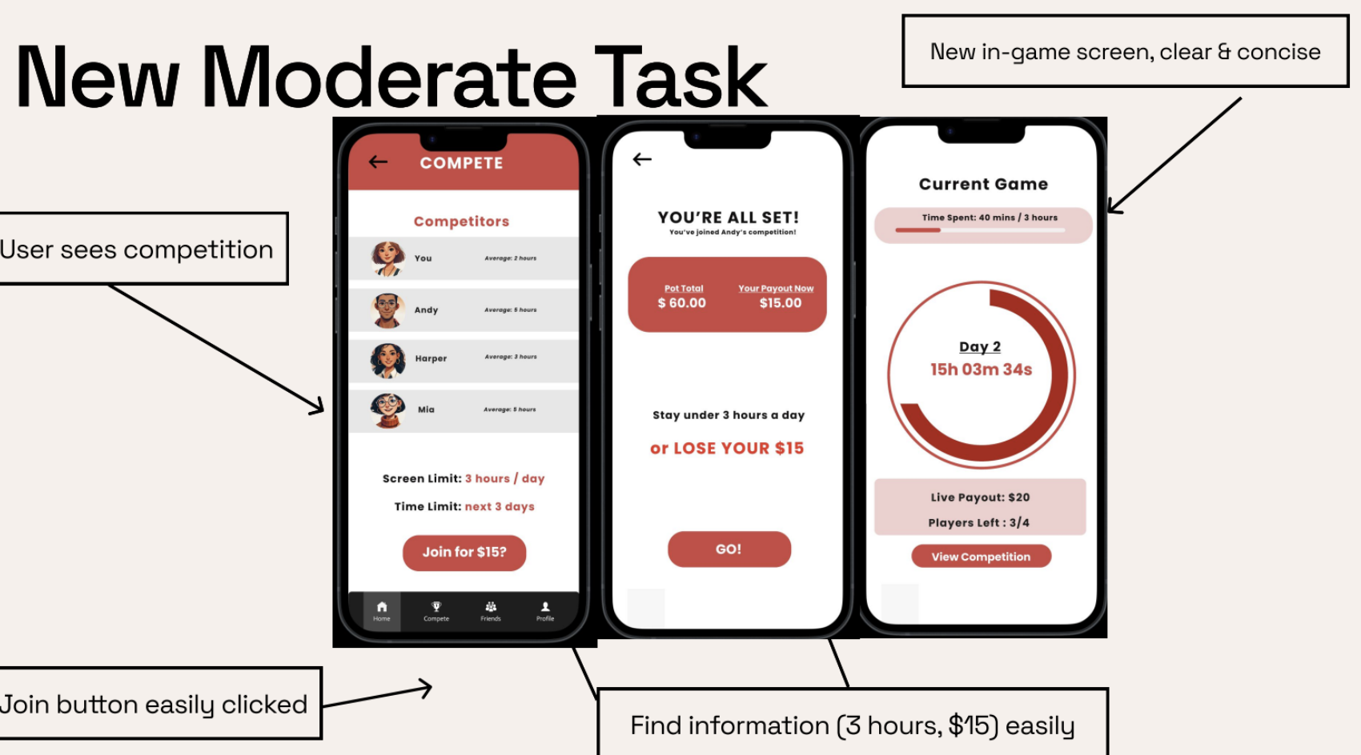

Finally, a major limitation that we noted was how the moderate task worked, before we wanted the viewing of competitors to only be done so post-competition and only at the discretion of the user who would be mandated to have a daily post, but this took away the spontaneity and added extra work to the user flow. To simplify this process, we added a join button which can be easily delineated and clicked and current game-screen; this screen only allows users to view their competition when inside a game to minimize distractions but also easily check their in-game status. Our rework followed Gestalt grouping of similarity and we also aimed to create better consistency between the color schemes and the competition flow; users should experience improved efficiency and learnability as the post-revision UX is much more intuitive.
Medium Prototype
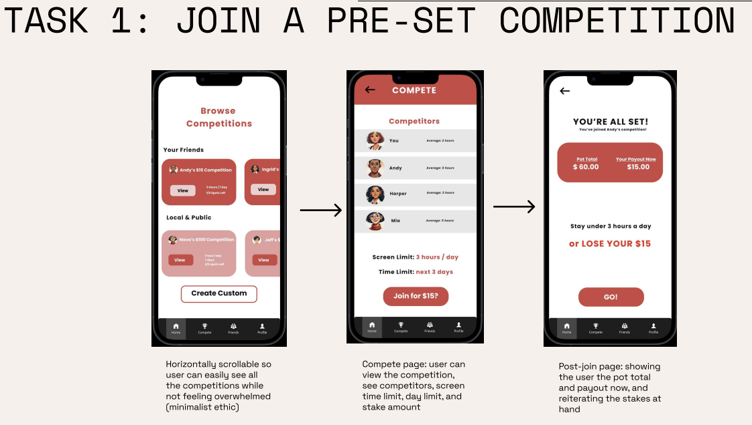
Built with Figma linking, it allowed us to first visualize which eventually became our “browse” competitions home page. It still allowed for users to see all details of competitions before joining them, but it simplified the UI more. We also deliberately separated out the Browse Competitions from the View Competition page, allowing users to commit to seeing more detail about a competition rather than being bombarded with high level detail all at once. This is also where we created a “post-join page”, that allowed users more time to think and check before committing their real money to a competition, decreasing risk of error.

Evolution of Tasks (Lo-Med-Hi)
We traded projects with other groups of classmates to complete in-depth heuristic evaluations, based on the heuristics that we discussed in class. Below, we’ll detail the major evolution of our tasks and rationale.
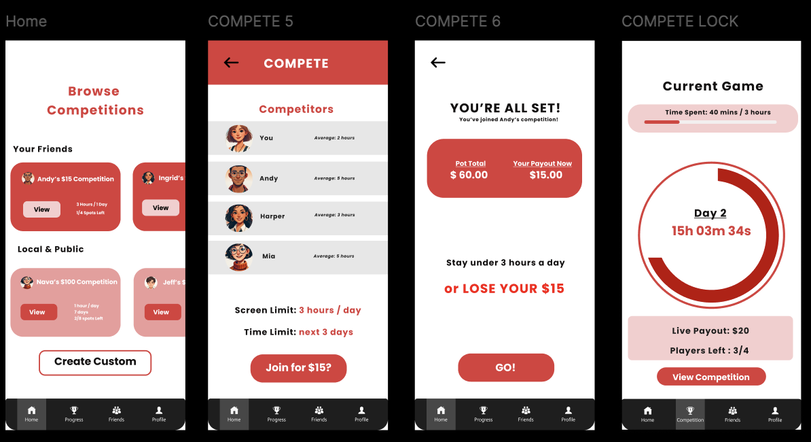

Med-fi Simple Task
Evolution of Simple Task Flow
Our simple task was joining a competition. After testing this prototype, we felt that it was a little bit cluttered; for example, the “Stay under 3 hours a day for 3 days” text took up the whole screen, giving the app a claustrophobic feeling. We prioritized whitespace and margins in our revision, moving text boxes as needed; and clarifying labels surrounding the game “Payout,” “time per day,” the degree of sharp colors, and more. We made significant changes from the Lo-medium fi as detailed in the prior section, and still felt like there was more we could’ve done; we continue to emphasize the use of Minimalism. The most notable of which is the Current Game screen, here we see the implication on efficiency as all the game info is in the top via Gestalt grouping, not requiring the user to split their eyes from both the top and bottom of the screen, and spend more time navigating. These details also make it much more learnable and understandable; the user knows the in-game status all time without having to do extra work on the app.

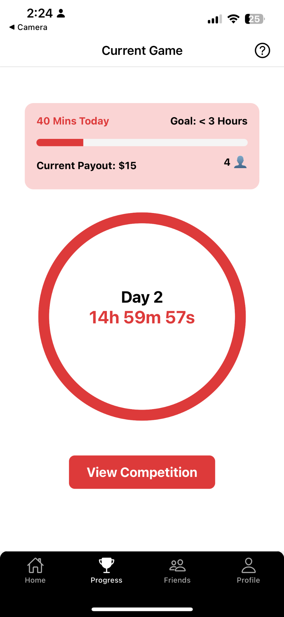
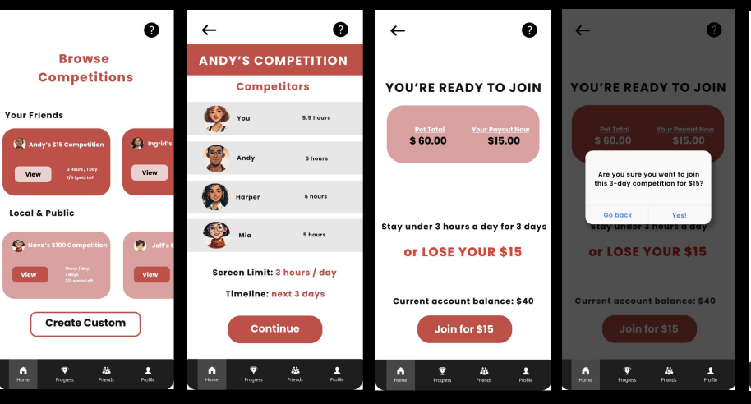
Hi-Fi Simple Task

Med-Fi Moderate Task
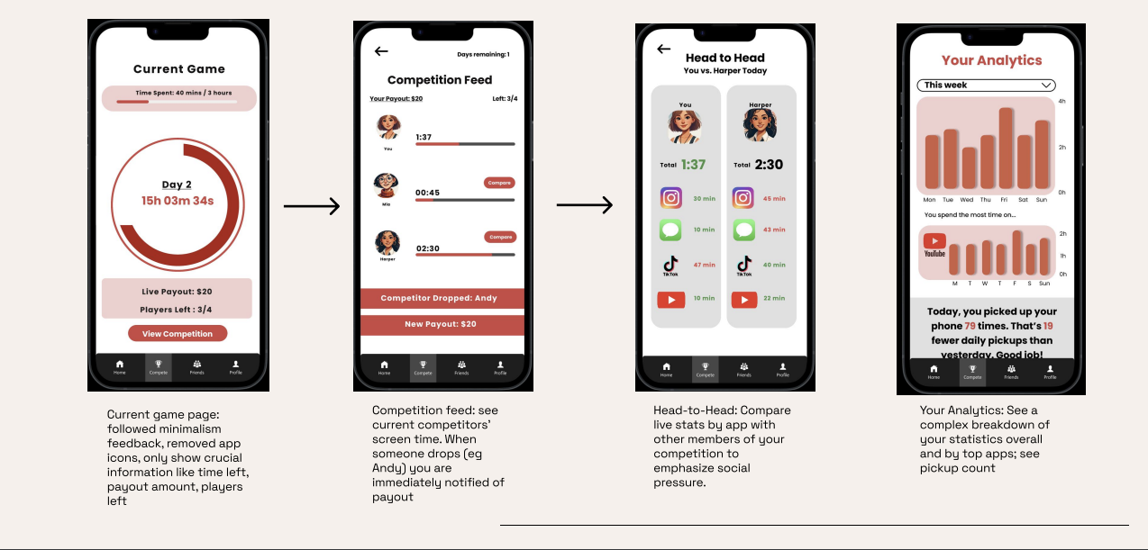

Evolution of Medium Task Flow
Our initial medium task flow focused on users being able to communicate on a screen time social media platform with competitors about competition progress and screen time. We included pages to directly post stats, opportunities to message and chat about stats, and a detailed analytics page to review one’s own overall progress. After testing the app, we realized we needed more spacing between important buttons.
The major changes that we made were evaluated based on a mix of heuristics and the design principles we covered in class from Gestalt to whitespace as we improved the user experience and the feedback we received from peers, TAs, and our section reviewer, Nava. We made significant changes to the Analytics page, as we delineated labels more clearly and added more contrast in text colors. For the head to head page, we cleaned out the gray backgrounds and used a grid like format, inspired by Fantasy Footballs, clean delineation to make the information more understandable. We pivoted toward minimalism, particularly on the in-game screen: here, we created a circular countdown to signify time left in a competition, and we removed app logos. The implication for efficiency is that fewer items on the screen mean that the user can move through the app faster, thus helping decrease their screen time. As for learnability, the simplified grid format in the Head to Head page is much more readable, allowing the user to enjoy a more relaxed learning curve while first using the app.

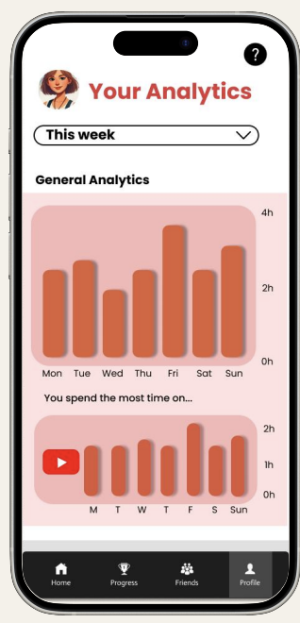
High-Fi Moderate Task:

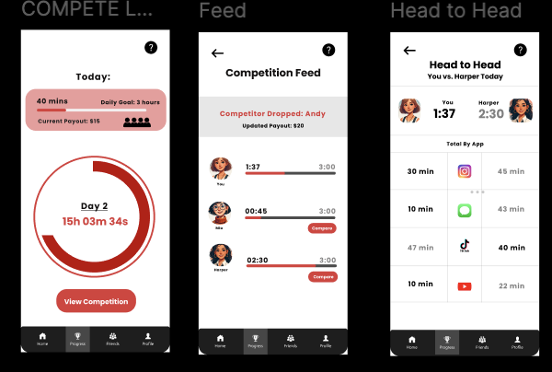

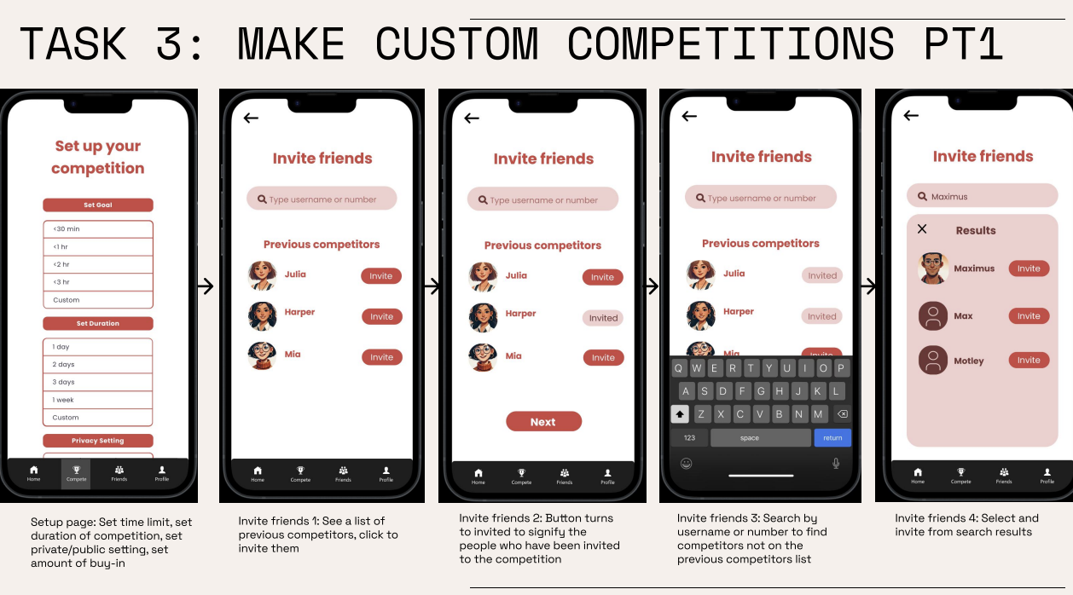
Med-Fi Complex Task:

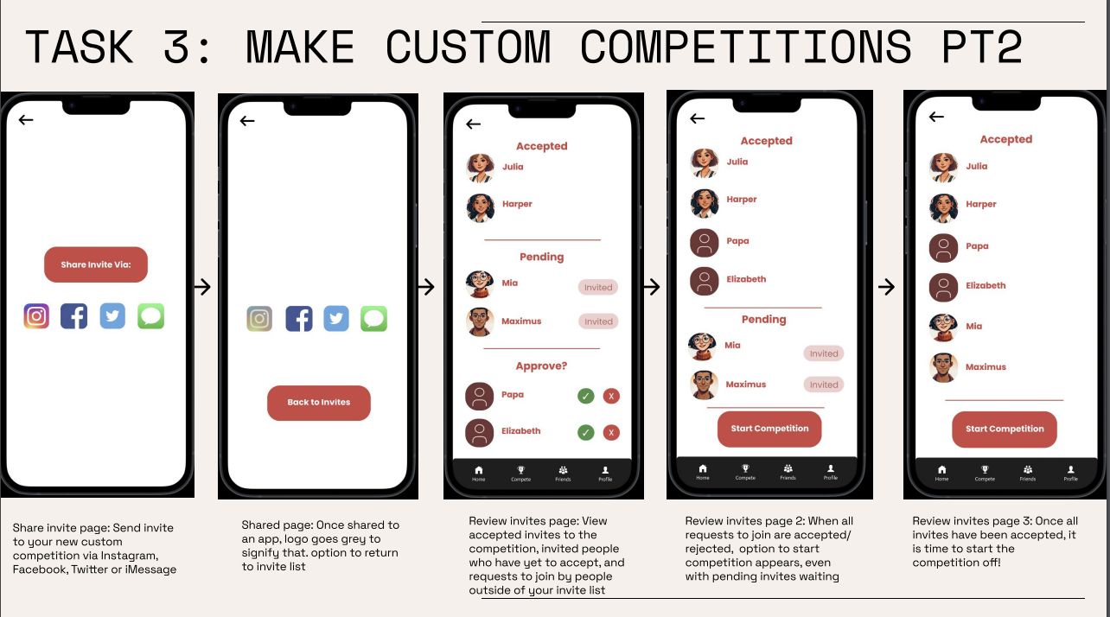

Evolution of Complex Task Flow
The complex task flow was intended to show the steps for creating one’s own competition. We emphasized the freedom to set screen time goals, invite friends inside and outside the app, and share invites outside the app. We also wanted a screen to monitor accepted/pending invitations. We did not make many significant changes to the complex task, because there were no significant problems found during evaluation.
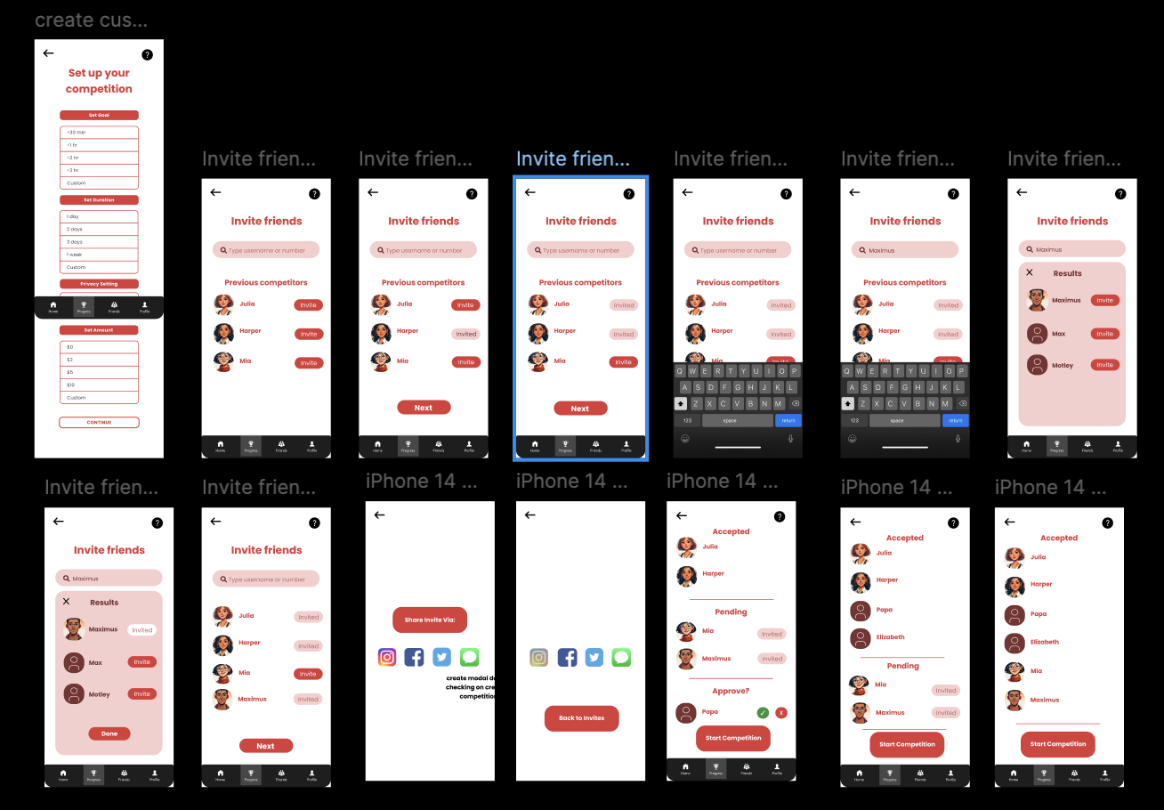
Hi-Fi Complex Task

Our Usability Goals
We had 2 main usability goals throughout given that our app aims to keep people off their phone. Our first goal was efficiency, because we wanted to minimize how long the user used the app to reduce unnecessary screen time on the app. Our second goal was learnability, which is how easy it is for new users to understand how the app works. We wanted to cater to as wide of an audience as possible.
Throughout, we wanted to emphasize minimalism, as users should not be addicted to the app or spend extra time navigating it, so we made our UI excessively simple, with gratuitous amounts of white-space, and with a muted color palette that centered around vermillion, black, white, and pastel pink. 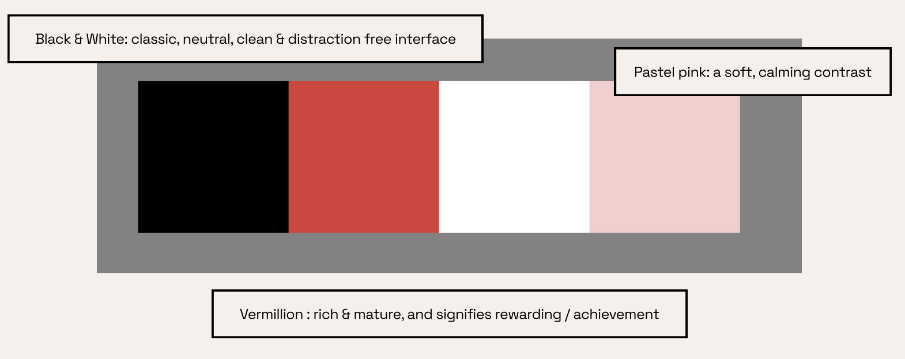

Our Heuristic Evaluations
We received a total of 29 violations and we evaluated them on task and severity through frameworks in the class. In the end, we made 24 revisions, and added several more of our own violations that we thought could be improved in our designs.
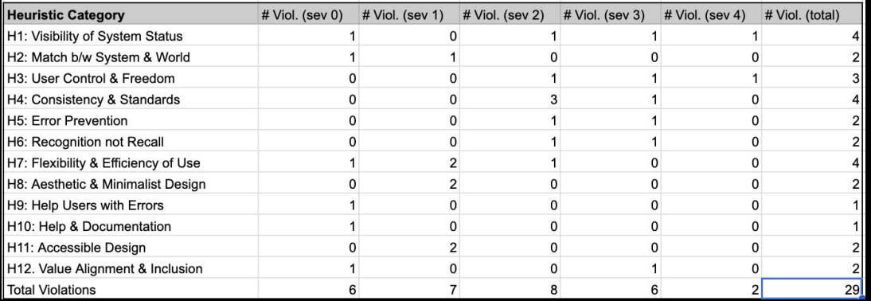
Breakdown of our heuristic violations by category and heuristic.
- 5: Severity 0 / Misunderstandings
- 10: Minor Severities (small fixes)
- 8: Major Severities (Sev 3 or 4)
- 6: Aesthetic Issues
The first Severity 4 violation we received was H3, that there was no back button when creating a custom competition. To fix this, we created a back button to take you back to a custom competition.
The second Severity 4 violation we received was H1, in that there was an absence of indicators of the location in the app that show the current location of the user. We fixed this by making the navbar current spot clear everywhere, with a clear and drastic value change. 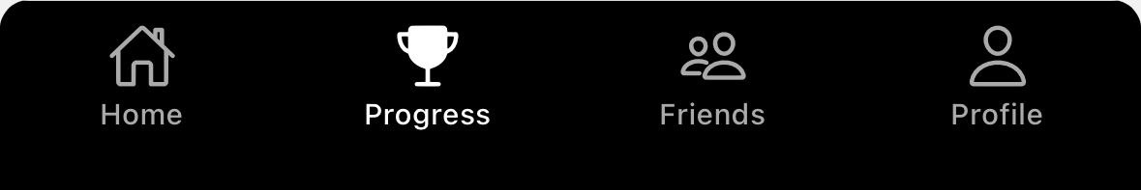
The first Severity 3 violation we received was H3, because the evaluators were confused whether the back button causes a user to drop out of the competition or just takes the user back to the previous page. To fix this, we got rid of the “You’ve joined a competition!” text and modified the flow of the app for clarity.
The second Severity 3 violation we received was H5, as the problem was that it was unclear once the user presses the join button that they will not be able to get their money back or if they can get a refund for their money if they drop out. To remedy this, we added a confirmation page to make it explicit that joining a competition is non refundable.
The third Severity 3 violation we received was H6, that past performance is not displayed when checking the competition feed. We did not change this, as we wanted to stay true to our value of minimalism and did not want to clog the screen with extraneous information that was not immediately pertinent to the competition. When a user is in a competition, we want them to only focus on the competition.
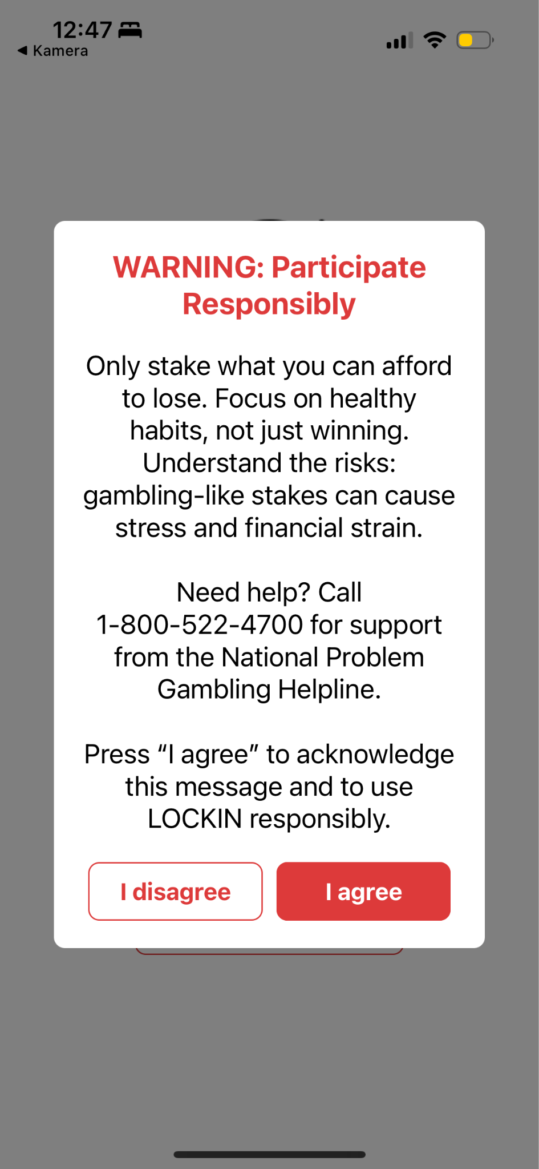
The fourth Severity 3 violation we received was H4, that the back button uninvites a friend to the competition after they have just been invited. We fixed this by making the back arrow take the user back to the set goals page instead.
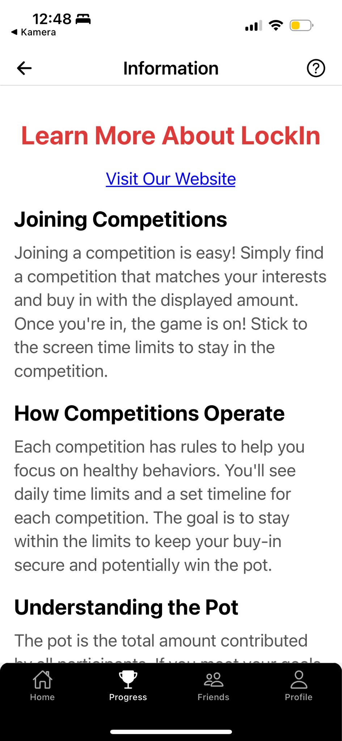
The fifth Severity 3 violation we received was H12, because the app lacked a warning to communicate that gambling related behaviors could be financially ruinous to users. To address this, we added a mandatory “participate responsibly” warning where you can't press agree without reading, and also included the gambling hotline right after the login page.
The sixth Severity 3 violation we received was H1, because we didn’t have a help screen anywhere. To address this, we added a help button in the top right corner of most pages, which would lead to a guide that would help the user learn how to understand the rules of the app and how to use it.

Values in Design
Our first value is simplicity. We used minimalist features and color palette to reduce extra time spent on LockIn. In the same vein, the main page is “locked” to access when in a competition with only the necessary game information. There is a possible conflict here with user-friendliness, since simplicity often means extra user comfort is excluded here. We addressed this challenge by iterating on the app until we found a comfortable balance between simplicity and user-friendliness, where users felt able to use the app but also where the app still felt minimalistic.
Our second value is inclusivity. We included diverse public competitions, and users can invite friends from outside the app. Users can also find a competition with any level of buy-in that works for them. There is an option for users to join no-cost competitions, to increase the level of inclusivity by making the app accessible even if a user cannot spend money.
Our third value is user-friendliness. We used a simple user interface with large imagery and buttons. Its features include a navbar, clear buttons, clear displays of goals, time metrics, game rules, and stakes throughout the competition. There is a possible conflict with simplicity, as increasing the user-friendliness can risk cluttering the screens.
The final value that we prioritized in our solution was flexibility. Users are allowed to customize the competitions they make and join, where we want users to join any kind of competition, tailored to them regardless of experience, expertise, and more to join and find. Users are allowed to join any competition, whether friend-made or public, at their discretion.

Final Prototype Implementation
We developed our final prototype implementation in React Native, using Expo to test out the user interface as we went. The final project was displayed as an Expo Snack. We used Git for version control, and HTML/CSS to style our app.
The pros of using the combination of React Native and HTML/CSS were that it was easy to find documentation when we ran into problems, because these are such widely used technologies, and that it was easy to manage the learning curve. We did not feel that there were any cons.
The pros of using Expo were that it was extremely convenient to scan the QR code and see our app live on our phones, and there was almost no learning curve. One con was that sometimes Expo wouldn’t update in real time, forcing us to quit Expo and run “npx expo start” again so that everything would reload.
The pros of using Git were that we could contribute to the code remotely, even when not in the same room, and it was very clear to use. We did not find that there were any cons.

Wizard of Oz Elements
The first Wizard of Oz element was the social network within the app, as we did not build out the ability to invite and interact between users. Next was the presence of other users in competitions; we did not build out the ability to invite and interact between users, so naturally “live competitions” are not actually live and do not contain other users. Third, LockIn Bucks/bank account linking was a Wizard of Oz element because the app imitates the process of having your bank account linked and adding new funds to one’s LockIn Bucks. Fourth was competition insights, as the prototype simulates the experience of tracking and interacting with other competitors’ data, but it does not actually have any implemented connection between other users of the prototype or their screen time data. Fifth is live screen-time insights and approval: in other words, having access to actual screen-time data on the user’s phone. The prototype simulates the process of approving access to screen time and displaying live data from this, but this is not a real part of the prototype. Sixth is recalculating live payout: the app is supposed to recalculate the payout when a person drops out from the competition and display it. We simulated that by changing the number between screens. Seventh is sharing to other apps: the prototype simulates the posting of competition invites or information on other apps, but this is not a functional process yet.

Hard-Coded Elements
The first hard-coded element was in the profile: the name Julia L, and the profile of the current user is hard-coded. Nobody else can login and there is only one username and password. The second is the data and analytics graphs: the data analytics and live tracking of one’s own and one’s competitors’ screen time is hard coded in the app, with current numbers serving as example values for a user to see at any given time. The third is pot and payout quantity; the winnings, buy-in and live payout numbers are all hard-coded and written in. The fourth is the choices to invite friends, as the choices of searchable friends list to invite to competitions are hard-coded. The fifth is analytics, as the month, week, 6 month and yearly screen time data overall and by app are hard-coded on the profile screen. The sixth is the user avatars: AI-generated avatars are hard-coded to represent user profiles. In reality, users would be able to set profile photos for themselves. For consistency, we hard-coded them as we do not have any real users on our app.

Reflection & Next Steps
Early on in the quarter, a surprising discovery through needfinding was that across age groups, while stressors vary hugely, almost everyone feels like their phone usage takes away from free time, adds to stress, and worsens mental health. This discovery was our impetus for targeting screen time as a method to increase overall well-being for users. In a similar vein, our early testing and brainstorming led us to think provocatively about what motivates people– and what might motivate them enough to truly stay off a device in their pocket, built to addict them.
Our own project evolved naturally over time, but the most surprising pivot we had to take was toward radical minimalist design. We all are excited by complex features, AI chatbots, and the usual buzzwords in the Stanford CS community, so it required us to override our first instincts to tone down the app design to match our goal of turning users away from their phones, rather than towards.
As we learned about the design process, we all were grateful to increase our familiarity with tools like React Native, Expo, and Figma. The practice every week in section with speaking aloud about design choices was new and worthwhile, and we enjoyed being able to dive so deeply into and have so much agency over a project.
If we had more time, we would love to add more control for users over competition-building. Particularly, during the Expo, we kept receiving feedback that people would particularly love to be able to compete about usage of one single app – and that overall screen time was less important to them than social media screen time, or too much use of specific time-waster apps like Tik Tok.
With more time, we would also love to build out our Wizard-of-Oz and hard-coded features, and to actually link the screen time API to our app, bringing the analytics and competitions to life. Creating a real in-app social network would also be next, enabling users to interact with and actually join competitions together.

It’s time to LockIn!

